ICS311- Database Management Systems

Instruction – Connecting to MySQL Workbench

Rajeev Goyal

**Select ‘MySQL Workbench 6.3 CE’ (Note: version number may be different in some cases)**

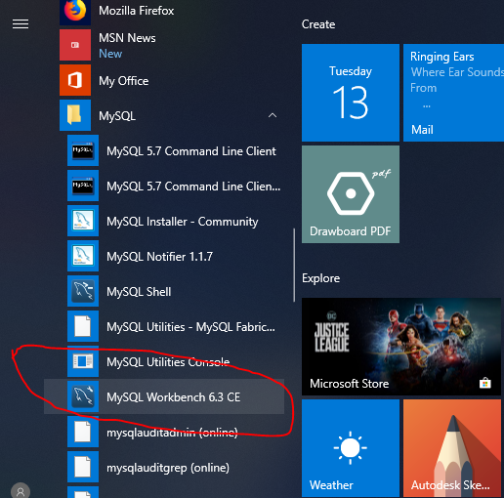

**You are logged into MySQL Workbench**

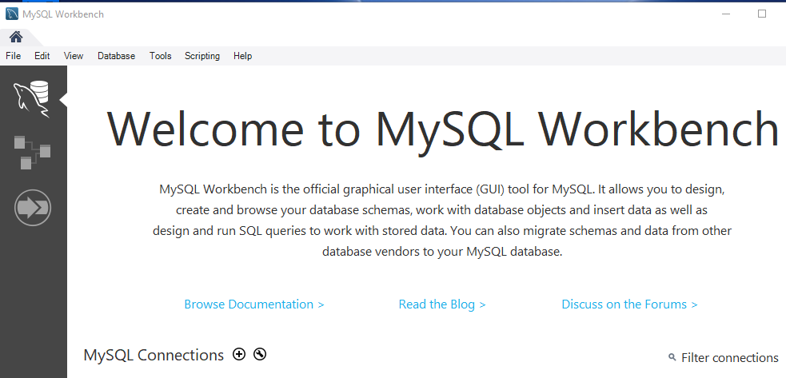

**Setup and save a Connection**

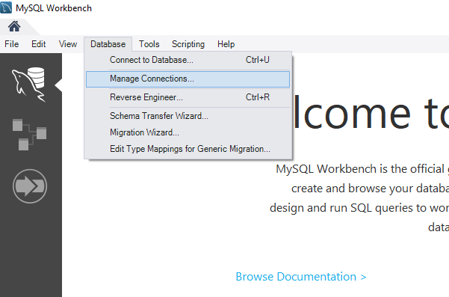

**Option 1 (Recommended – use your local database)**

* **Click New**
* **Enter a Connection Name of your choice**
* **Connection Method: Select from drop down : ‘Standard TCP/IP ’**
* **Hostname: localhost**
* **Port: 3306 (***Use the default provided on your screen***)**
* **Username: root**
* **Enter your Password by clicking on “Stored in Vault”**
* **Click on Test Connection –** *you should see a success message. If not, check your user name and password.*
* **Click Close once completed**

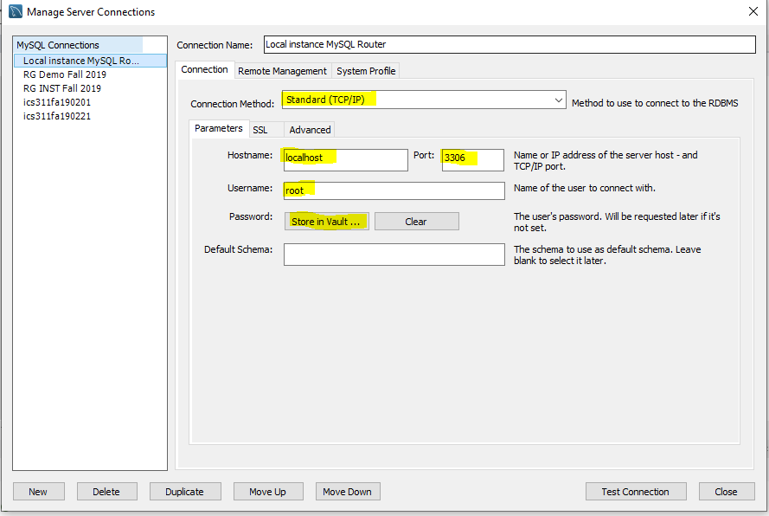

* **Option 2 (To be used only if instructed)**
* **Click New**
* **Enter a Connection Name of your choice**
* **Connection Method: Select from drop down : ‘Standard TCP/IP over SSH’**
* **Enter other fields as highlighted below**
* **Use your OS and DB user name and password provided to you. Password stored in Vault.**
* **Click Close once completed**

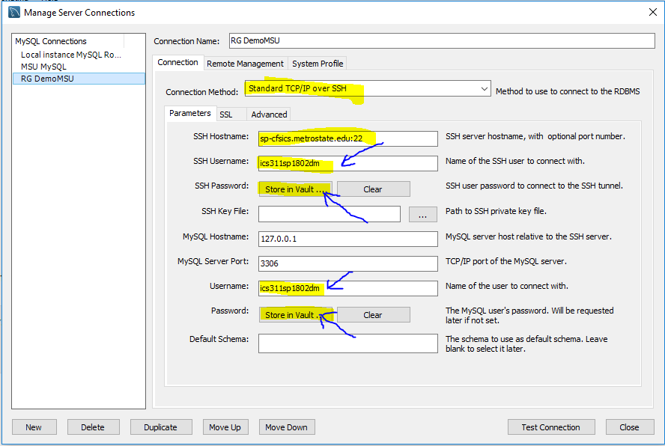

**Now Connect to Database**

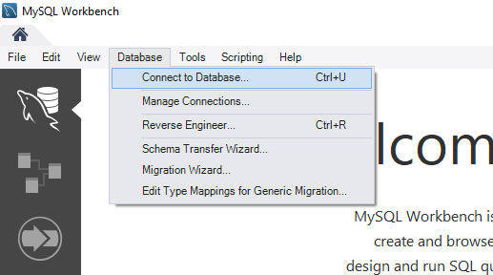

**In the field Stored Connection, select your connection name, which you had setup earlier**

**Click OK.**

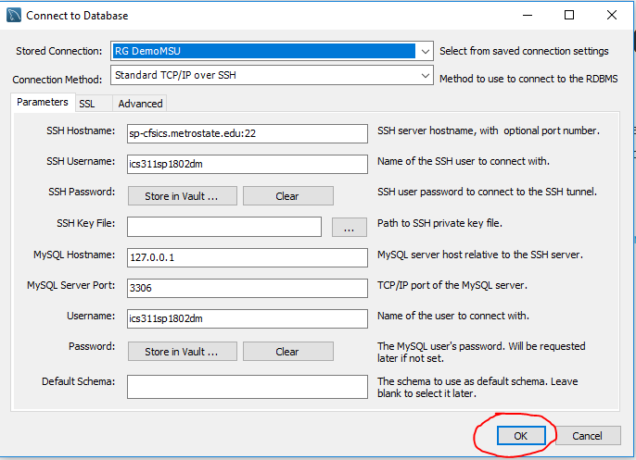

**You are now in MySQL. In the left window, you can see your Database**

